EXPERIMENT – 3

Identifying interaction design and functional layout. Practical implementation of interaction design and functional layouts

Title : AI-Powered Smart Travel Planner Chosen Screen for

Team Details :
1) Surya R - 23MIS0592
2) PAVAN KALYAN K – 23MIS0563
3) Mohanakumar L - 23MIS0516

Submitted by:
Name: SURYA R
Reg No: 23MIS0592

1.Aim
To design and develop an interaction design prototype for the user and travel companion module of an AI travel assistant with a functional layout, consistent user interface, intelligent AI chat support and personalized travel assistance.
2.Objectives
- To understand the principles of interaction design and functional layout in developing an AI powered travel planner
- Translate user requirements into a structured interactive prototype using figma
- Design an AI chatbot interface that supports personalized travel assistance and recommendation.
- Apply consistent rules like button placements, label, icon, navigation and color scheme across all screens
- Implement a navigation system that provides seamless access to AI chat, explore nearby, save trip, notification, profile and preferences and settings.
- Integrate a adaptation engine to personalize the interface and recommendation based on the users destination and travel context
- Evaluate whether the interface supports an accurate for first time and returning users.
3.Theory
3.1 Interaction design
Interaction Design is the process of designing meaningful and efficient communication between users and digital system. It focus on how users interact with an application through buttons, menus, navigation, forms and feedback mechanism. A well designed interaction enables user to complete the tasks easily while minimizing confusion and error.
In travel planner application, interaction design ensures that users can communicate with the AI assistant, explore nearby places, manage trips, receive notification , update personal preferences and configure application setting through a simple interface.
3.2 Functional layout
A functional layout refers to the logical arrangement of interface components such as navigation menus, buttons, search bar, content section and user controls. The layout should guide users naturally toward completing their task without huge complexitiy.

3.3 Consistency principles
consistency means a control looks and behaves the same way everywhere it appears. Three rules are commonly applied:
- Placement consistency- navigation buttons, search options and primary action remain in fixed position on every screen
- Wording consistency- the same label such as save, cancel, explore,chat are used consistently across all modules
- Color consistency- a uniform color palette is followed where blue represent primary action, green indicates successful operation and red for warning or delete action.

3.4 Mental model
In travel planner application, once user learns how to interact with one module like ai travel assistant then they can easily use other modules like explore nearby, saved trips and settings because the navigation structure, button placement, color and interaction pattern remain consistent.
4 Software/ Tools used
- HTML
- CSS
- JS
- Figma

5.Activity 1 design and prototype the interaction
5.1 Step-1 identify user requirements
S.no | User requirement | Screen/interaction it maps to
1 | The user should be able to communicate with the AI assistant to obtain travel recommendation, suggestions and answer to travel related questions | AI travel assistant (Chat)
2 | The user should be able to discover nearby tourist attraction, hotels, restaurant, transport and other interest based on the user location | Explore nearby
3 | The user should be able to save favourite locations and planned trips for reference and quick access | Saved trips
4 | The user should receive notification regarding trip remainders, weather updates, alerts and announcements | Notification
5 | The user should be able to manage personal information, travel interest, preferred destination, language, budget, and preferences | Profile and preferences
6 | The user should be able to configure settings such as notification, privacy, themes, language and account settings | Settings

5.2 Step-2 Map the screen flow
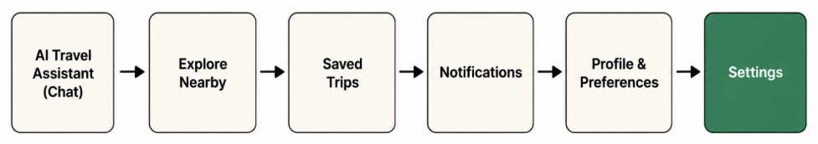

5.3 Step-3 Build the prototype
The travel planner prototype is implemented as an interactive design consisting of interconnected screens related to destination discovery. A navigation bar for easy access to Home, AI assistant, explore nearby, saved trips, profile and preferences and settings. The navigation bar allows user to switch easily between screens, while maintaining the same layout, button placement, and color scheme throughout the application. This ensures a simple, predictable and user friendly experience.

6. Activity 2 Apply and verify consistency
Activity 2 was implemented by defining common interaction rules and maintaining them throughout the destination search workflow.
6.1 Consistency rules applied
Rule | Where it appears | How it was kept consistent
Button placement | All screens | Primary actions remain in the same position, with the back button at the top left and main action at the top right
Label wording | AI chat, saved trips, settings | Common label such as save,cancel, explore and update are used consistently throughout the application
Color scheme | All screens | Blue is reserved for primary actions, green indicates high AI confidence, and orange represents medium confidence.
Navigation | All modules | The bottom navigation bar remains identical across every screen for easy access to all feature

6.2 How this builds an accurate mental model
The travel planner application follows the same layout, navigation, label and color scheme across all modules. As users become familiar with one feature, they can easily navigate the others without additional learning. This consistency improve useability, reduces errors and provides a smooth and predictable travel planning experience.

7. Output/Result
The completed travel planner prototype successfully demonstrates the AI travel assistant, explore nearby, saved trip, notification, profile and preferences and settings. The application follows a consistent design with uniform navigation, button placement, label and color scheme across all screens. Users can easily navigate between modules, manage travel information and interact with the application through a simple and intuitive interface.
7.1 Self-evaluation checklist
Check | Result
Is the primary action in the same position on every screen? | Yes
Are navigation menus consistent throughout the application? | Yes
Are label and icons used consistently? | Yes
Is the color scheme maintained across all screen? | Yes
Can user easily navigate between the pages? | Yes

